1. GridView.count를 사용하여 리스트뽑기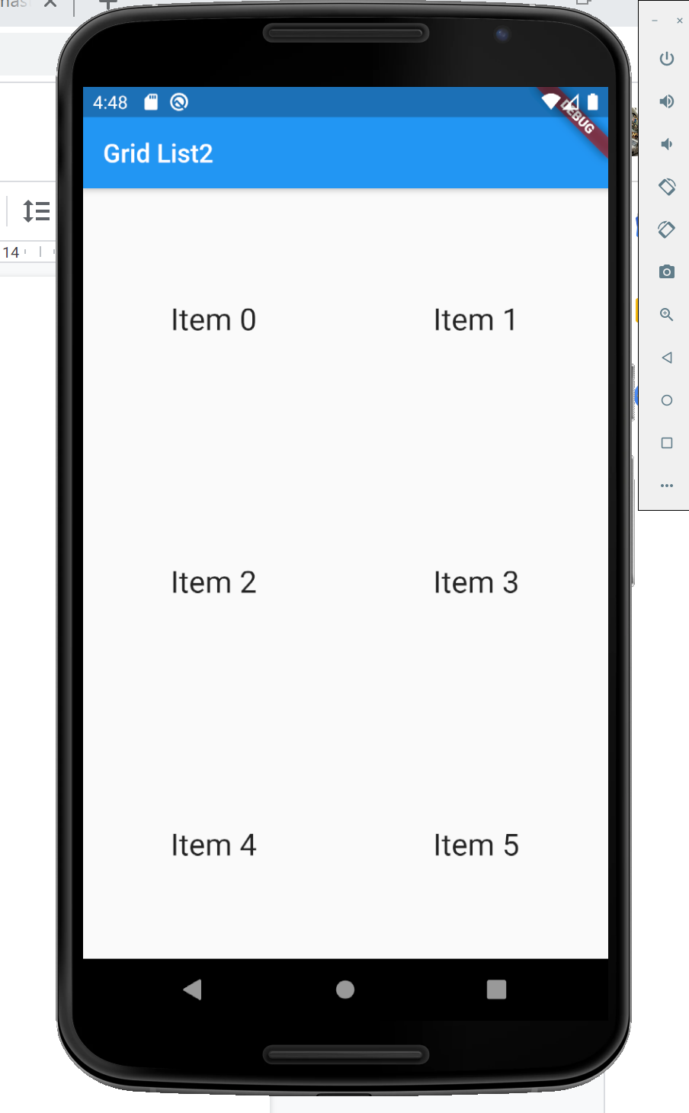

import 'package:flutter/material.dart';

void main() => runApp(MyApp());

class MyApp extends StatelessWidget {

@override

Widget build(BuildContext context) {

// final title = 'Grid List'; // final 변수를 사용해서 하단부에서 사용

return MaterialApp(

title: "Grid List1",

home: Scaffold(

appBar: AppBar(title: Text("Grid List2")), // 실 타이틀

body: GridView.count(

crossAxisCount: 2, // 한행에 분할할 화면 갯수

children: List.generate(10, (count) {

return Center(

child: Text(

'Item $count',

style: Theme.*of*(context).textTheme.headline,

),

);

}),

),

),

);

}

}

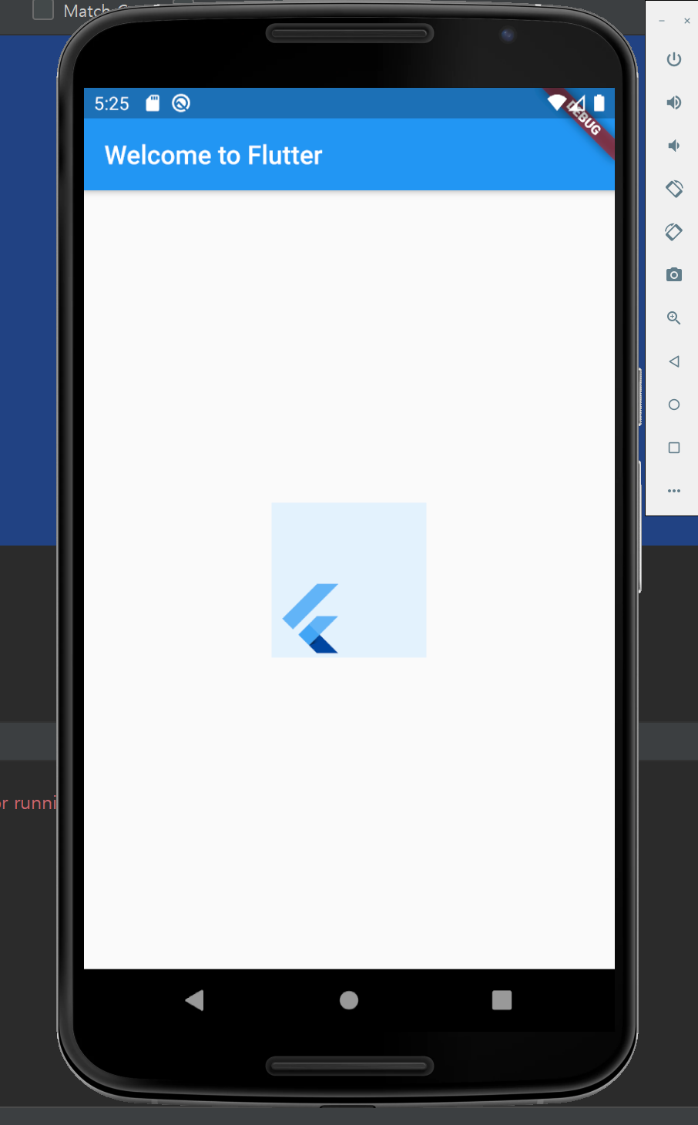

1. Align Class이용

import 'package:flutter/material.dart';

void main() => runApp(MyApp());

class MyApp extends StatelessWidget {

@override

Widget build(BuildContext context) {

return MaterialApp(

title: 'Welcome to Flutter',

home: Scaffold(

appBar: AppBar(

title: Text('Welcome to Flutter'),

), // Header부분

body: Center(

child: Container(

height: 120.0,

width: 120.0,

color: Colors.*blue*[50],

child: Align(

alignment: Alignment.*bottomLeft*,

child: FlutterLogo(

size: 60,

),

),

),

),

),

);

}

}

3.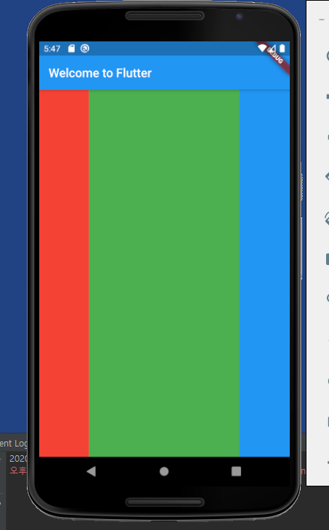

import 'package:flutter/material.dart';

void main() => runApp(MyApp());

class MyApp extends StatelessWidget {

@override

Widget build(BuildContext context) {

return MaterialApp(

title: 'Welcome to Flutter',

home: Scaffold(

appBar: AppBar(

title: Text('Welcome to Flutter'),

),

body: Align(

alignment: Alignment.*bottomLeft*,

child: **Row**(

children: <Widget>[

Expanded(

flex: 2, // 20%

child: Container(color: Colors.*red*),

),

Expanded(

flex: 6, // 60%

child: Container(color: Colors.*green*),

),

Expanded(

flex: 2, // 20%

child: Container(color: Colors.*blue*),

)

],

),

),

),

);

}

}